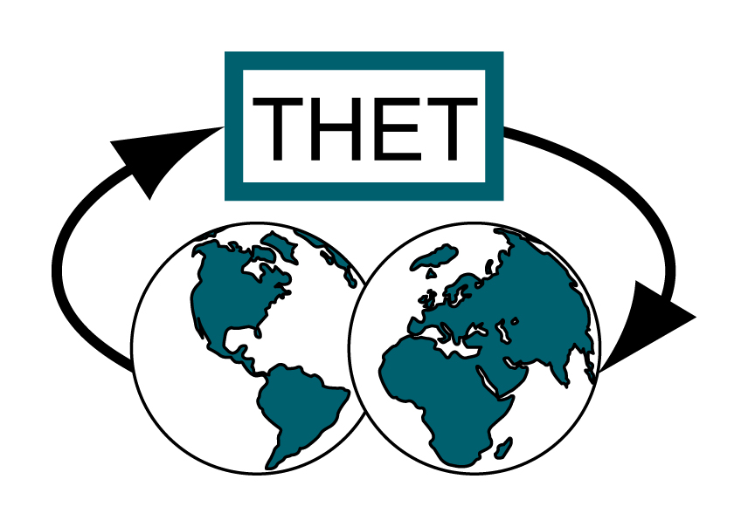

Tropical Health and Education Trust
BOOKING FORM

THET’S NATIONAL CONFERENCE FOR
HEALTH LINKS 2009

Cardiff University Campus, Humanities Building,
Colum Drive, Cardiff, CF10 3EU

Thursday 2nd April 2009, 10:30-17:00

Name

Job title

Organisation

Address

E-mail

Telephone/Mobile

Any special requirements

The cost of this event is £20.00 (£15.00 for students). Please make cheque payable to The Tropical Health and Education Trust, and forward payment with completed booking form.

Please return this form and payment to
Sharon Horder
The Tropical Health and Education Trust (THET)
5th Floor
1 Wimpole Street
London
W1G 0AE
E-mail: sharon@thet.org

Inquire about bursaries if you would like to come, but would have difficulty raising funds to attend. Please email sharon@thet.org

